DAY 5 ASSIGNMENT
DATABASES – NORMALISATION AND DATA DEFINITION
Scenario: Set 3 – Hospital Patient Records
Submitted by: Brindha
Date: 11 November 2026
SET 3 – HOSPITAL PATIENT RECORDS
1. Normalisation to 3NF
Introduction
Normalisation is the process of organizing data in a database to reduce data duplication and avoid insertion, update, and deletion anomalies.
For the Hospital Patient Records system, the data is divided into five separate tables:
- Patient
- Doctor
- Department
- Visit
- Billing
Table Decomposition
1. Patient Table
Stores patient details.
Column | Description
patient_id (PK) | Unique patient ID
patient_name | Name of the patient
address | Patient address
2. Doctor Table
Stores doctor details.
Column | Description
doctor_id (PK) | Unique doctor ID
doctor_name | Name of the doctor
department_id (FK) | Department ID
3. Department Table
Stores department details.
Column | Description
department_id (PK) | Unique department ID
department_name | Name of the department
4. Visit Table
Stores patient visit details.
Column | Description
visit_id (PK) | Unique visit ID
patient_id (FK) | Patient ID
doctor_id (FK) | Doctor ID
visit_date | Date of visit
diagnosis | Patient diagnosis
prescription | Prescribed medicine
5. Billing Table
Stores billing information.
Column | Description
bill_id (PK) | Unique bill ID
visit_id (FK) | Visit ID
bill_amount | Total bill amount
status | Billing status
How 3NF is Achieved
- First Normal Form (1NF): Each column contains atomic values, and there are no repeating groups.
- Second Normal Form (2NF): Every non-key attribute depends on the whole primary key. Each table uses a single-column primary key.
- Third Normal Form (3NF): There are no transitive dependencies. Patient, doctor, department, visit, and billing details are stored separately.
Explanation of Decomposition
The original hospital records are divided into separate tables to avoid storing the same patient, doctor, and department information repeatedly.
Primary keys uniquely identify each record, while foreign keys connect related tables.
This improves data consistency, reduces duplication, and makes database maintenance easier.

2. Database Schema with Constraints
SQL Query – Database Creation
CREATE DATABASE hospital_db;
USE hospital_db;
SQL Query – Department Table
CREATE TABLE Department (
department_id INT PRIMARY KEY AUTO_INCREMENT,
department_name VARCHAR(100) NOT NULL UNIQUE
);
SQL Query – Doctor Table
CREATE TABLE Doctor (
doctor_id INT PRIMARY KEY AUTO_INCREMENT,
doctor_name VARCHAR(100) NOT NULL,
department_id INT,
FOREIGN KEY (department_id)
REFERENCES Department(department_id)
);
SQL Query – Patient Table
CREATE TABLE Patient (
patient_id INT PRIMARY KEY AUTO_INCREMENT,
patient_name VARCHAR(100) NOT NULL,
address VARCHAR(255)
);
SQL Query – Visit Table
CREATE TABLE Visit (
visit_id INT PRIMARY KEY AUTO_INCREMENT,
patient_id INT NOT NULL,
doctor_id INT NOT NULL,
visit_date DATE NOT NULL,
diagnosis VARCHAR(255),
prescription VARCHAR(255),
FOREIGN KEY (patient_id)
REFERENCES Patient(patient_id),
FOREIGN KEY (doctor_id)
REFERENCES Doctor(doctor_id),
CHECK (visit_date >= '2000-01-01')
);
SQL Query – Billing Table
CREATE TABLE Billing (
bill_id INT PRIMARY KEY AUTO_INCREMENT,
visit_id INT NOT NULL UNIQUE,
bill_amount DECIMAL(10,2) NOT NULL
CHECK (bill_amount >= 0),
status VARCHAR(20) DEFAULT 'OPEN',
FOREIGN KEY (visit_id)
REFERENCES Visit(visit_id)
);

Constraints Used
- PRIMARY KEY: Uniquely identifies each record.
- FOREIGN KEY: Establishes relationships between tables.
- NOT NULL: Prevents a column from storing NULL values.
- UNIQUE: Prevents duplicate values.
- CHECK: Ensures that the given condition is satisfied.
- DEFAULT: Automatically assigns a value when no value is provided.
The Visit table validates dates from 1 January 2000 onwards. The Billing table prevents negative bill amounts and automatically assigns the status OPEN when no status is specified.
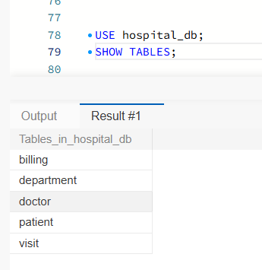
Screenshot 1 – Database and Tables

Screenshot 2 – Table Structures
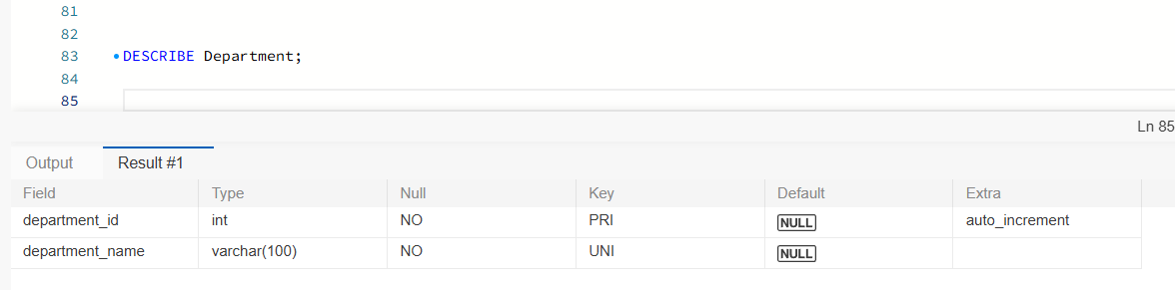

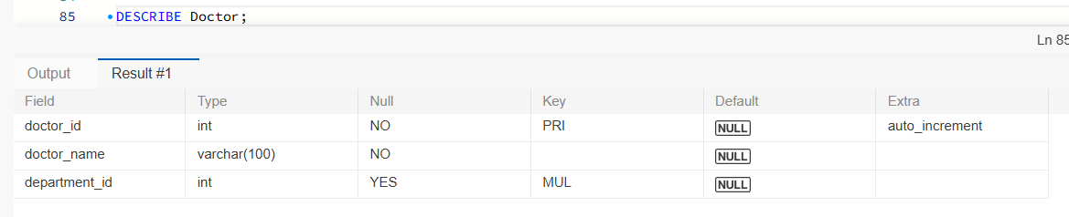

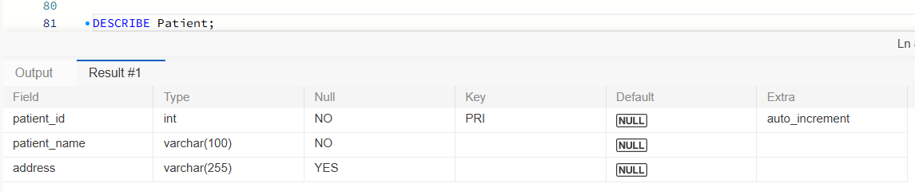

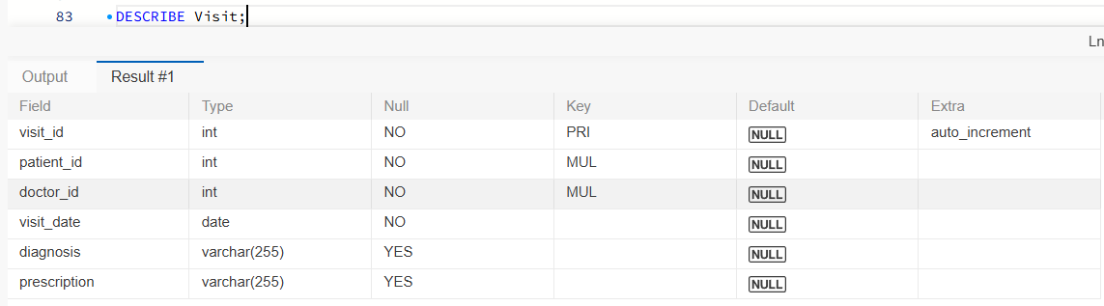

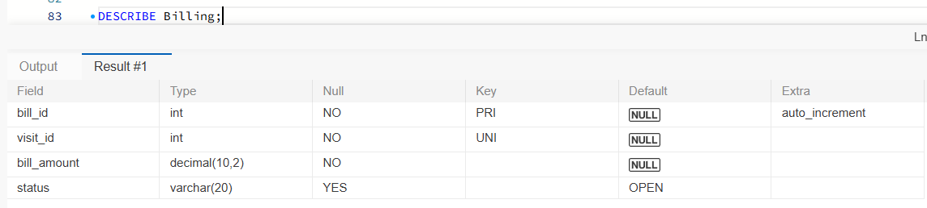

3. Database and Table Management
A. Creating a User-Defined Database
A user-defined database can be created using the CREATE DATABASE command.
CREATE DATABASE hospital_db;
To select the database:
USE hospital_db;
B. Renaming a Table
The RENAME TABLE command is used to change the name of an existing table.
Example:
RENAME TABLE Patient TO Patient_Details;
To change it back:
RENAME TABLE Patient_Details TO Patient;
C. Dropping a Database
The DROP DATABASE command permanently removes a database and its tables.
DROP DATABASE hospital_db;
Note: This command is destructive. It should only be executed on a test database when deletion is intended.
D. Recreating a Database
After dropping the database, it can be created again using:
CREATE DATABASE hospital_db;
USE hospital_db;
The tables and records must be created and inserted again.
What Happens to Database Files?
- Creating a database creates the required database storage structures.
- Renaming a table changes its name in the database.
- Dropping a database removes its database objects and stored data.
- Recreating a database creates a new, empty database.
Database files are managed by MySQL internally. They should not be manually deleted or modified.

4. Inserting, Updating, Deleting and Retrieving Data
A. Inserting Department Records
INSERT INTO Department (department_name)
VALUES
('Cardiology'),
('Neurology'),
('Orthopedics'),
('Pediatrics');
B. Inserting Doctor Records
INSERT INTO Doctor (doctor_name, department_id)
VALUES
('Dr. Arun', 1),
('Dr. Priya', 2),
('Dr. Kumar', 3),
('Dr. Meena', 4);
C. Inserting Patient Records
INSERT INTO Patient (patient_name, address)
VALUES
('Ravi', 'Coimbatore'),
('Priya', 'Madurai'),
('Karthik', 'Chennai'),
('Anitha', 'Trichy');
D. Inserting Visit Records
INSERT INTO Visit
(patient_id, doctor_id, visit_date, diagnosis, prescription)
VALUES
(1, 1, '2026-11-05', 'Heart checkup', 'Medication A'),
(2, 2, '2026-11-06', 'Headache', 'Medication B'),
(3, 3, '2026-11-07', 'Bone pain', 'Medication C'),
(4, 4, '2026-11-08', 'Fever', 'Medication D');
E. Inserting Billing Records
INSERT INTO Billing (visit_id, bill_amount)
VALUES
(1, 1500.00),
(2, 1200.00),
(3, 2000.00),
(4, 800.00);
The billing status is automatically set to OPEN because of the DEFAULT constraint.
F. Updating Patient Details
The UPDATE command modifies existing records.
UPDATE Patient
SET address = 'Salem'
WHERE patient_id = 1;
This updates the address of the patient whose ID is 1.
G. Deleting a Record
The DELETE command removes a record from a table.
DELETE FROM Patient
WHERE patient_id = 4;
This is an example query only. Execute it only if you intend to delete that patient and have handled any related visit and billing records first.
H. Retrieving Patients Who Visited in November 2026
SELECT Patient.patient_name,
Visit.visit_date,
Visit.diagnosis
FROM Patient
JOIN Visit
ON Patient.patient_id = Visit.patient_id
WHERE MONTH(Visit.visit_date) = 11
AND YEAR(Visit.visit_date) = 2026;
Explanation: This query joins the Patient and Visit tables and retrieves the patients who visited the hospital during November 2026.
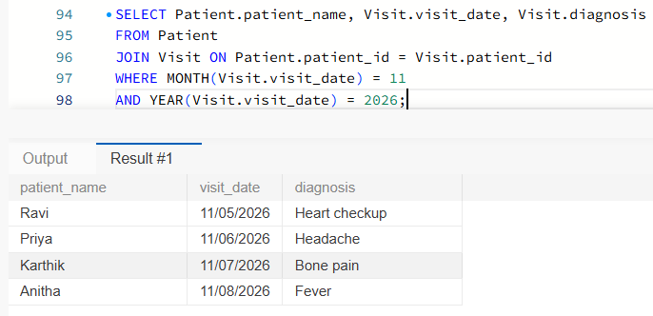
Screenshot 3 – Patient Visit Details

I. Retrieving Doctors by Department
SELECT Doctor.doctor_name,
Department.department_name
FROM Doctor
JOIN Department
ON Doctor.department_id = Department.department_id;
Explanation: This query joins the Doctor and Department tables to display each doctor's name along with their department.
Screenshot 4 – Doctors by Department
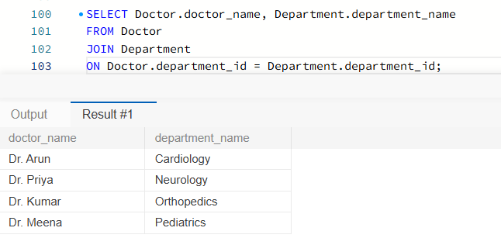
5. SQL vs NoSQL Comparison
SQL and NoSQL are two different types of database management systems.
Feature | SQL | NoSQL
Structure | Relational tables | Documents, key-value, graph or column-based
Consistency | Supports strong consistency and transactions | Depends on the database; can support strong or eventual consistency
Scalability | Commonly scales vertically, with horizontal scaling also possible | Commonly designed for horizontal scaling
Typical Use | Banking, hospital and employee management systems | Social media, real-time applications and large-scale data systems

Explanation
SQL Databases:
- Store data in structured tables.
- Use SQL to retrieve and manage data.
- Support relationships using primary and foreign keys.
- Suitable for applications that require structured data and reliable transactions.
NoSQL Databases:
- Store data in flexible formats.
- Can handle large volumes of varied data.
- Often support horizontal scaling across multiple servers.
- Suitable for applications with flexible data structures and changing requirements.

